

***ASSIGNMENT 1 OF iOS DEVELOPMENT***

***COURSE CODE- MAD 400***

***PROGRAM CODE- MAD2101MA***

***SUBMITTED TO - Manhar Kapoor***

**SUBMITTED BY – Gurpinder Kaur**

***Swift***

Swift is a compiled programming , multi-paradigm language. This language is developed by Apple Inc as well as by open source community. it was designed by Doug Gregory, john McCall, ted kremenek, Chris lattner, apple inc and by Joe Groff. It was initially appeared in the year 2014 on 2nd June. It is typically static, strong, inferred language in typing. The operating system which the language support are Linux, android, windows 10 and apple’s operating system which are iPadOs, macOS, tvOS, watchOS, iOS. The official website of swift is swift.org. Swift is made as the replacement of objective C language because the language objective c does not have modern features as well as it was unchanged. Swift is the best to write code for different software’s which may related to phones, servers, desktops or any other thing which executes the code. Swift is the user friendly industrial-quality language which is most enjoyable just like the scripting language.

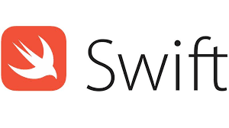

Swift reduces the errors by using different programming patterns like the initialization of variables are always completed before the usage. Control recovery is authorized by error handling from the failures that are unexpected. Nil values are clearly managed and it is ensured by optional. Apart from it memory is handled automatically in swift and integer is always checked.

***Objective-C***

Objective-c language is object oriented which is based on objects and general purpose language which is used for to add the Smalltalk style like messaging into the C language. It was developed by Brad Cox as well as by Tom Love in the year 1980. The official website of this language is developer.apple.com. Basically it is cross platform operating system language. Apart from it objective-C is the static, dynamic and weak in type. Next choose this language for its operating system which is Next STEP. Apple supports this language to made macOS and Ios applications. The programs of objective-C is not dependent on the API of Apple as it is build for the non-apple operating system so that’s why the program can compiled on any platform which is authorized by GNU GCC or LLVM/Clang. We can say that it support different platforms. .m extension is used by the program of Objective-C when it is denoted. Apart from it, .h extension is used by the headers or by the interface just like the header files in c language. The objective C++ files use .mm extension whenever they are defined.

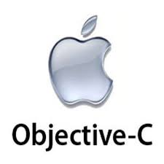

The main feature of this language is that sizzling offers classes to change on runtime. Basically it provides dynamic runtime. The categories in Objective-C gives the authority to add other functionality into the object without changing subclass or the real object. The methods are added into the actual class with the help of handy tool like NS String. The objective-C is the popular language and it comes at the 20th position.

***Test Flight***

Test flight is currently handled by the Apple Inc. Basically it is the online service which is used for installing the applications over-the-air as well as for the testing the different mobile applications. it only allows the ios developer as it is related to apple inc. we can say that test flight is used for beta testing. Firstly, developers needs to sign up to send the apps to beta testers either it can be internal or external or they send their feedback after testing to the developer. Apart from it,

The SDK of test flight gives the authority to the developer that they can receive crash reports, tester feedback and remote logs. The actual author of this application was Trystan Kosmynka and Benjamin Satterfield. The operating systems are ios, tvOS, and iPods. The official website of the test fight is developer.apple.com. Moreover, it has freeware license. In the beginning the test fights only support iOS and android testing. After that, in the year 2014, Apple withdraws the support from Android. Mostly the applications are published using Xcode for the test flight since 2015 and iTunes Connect is used to invite testers. Approximately 10, 000 external beta testers as well as more than 25 internal testers and each have more than 10 devices can download and test the build application after the invention. At the same time, more than 100 applications can be tested which can be both internal and external.



The all testers can be grouped or individual. We can invite only a 10,000 testers through sharing public link or by email and it is the limit which is already set. Test flight is free if you are the beta testers but on the other side if you are developer that you have pay for your program. Different apps like whatsapp Messenger, whatsapp business are the supported apps which work with test flight.

***Apple Inc***

Apple Inc is multinational American technology company which is expert in computer software, consumer electronics as well as in online services. Apple is biggest company in all over the world. Its total revenue in the year 2020 was 274.5 billion dollars. It comes in the category of world’s most valuable company from the January 2021. Apart from it, it is also comes at the position four in largest pc vendor which is noticed by unit sales. Apple comes in the category of one of the top five information technology business in America with Microsoft, Amazon, face book and Google. Interestingly, it is 4th highest Smartphone producer. This company is founded in the year 1976 on 1st April. The three main founders were Steve jobs, Steve Wozniak, Ronald Wayne. In the year 2021, 512 retail stores of apple are noticed. Currently its CEO is Tim Cook and Coo is Jeff Williams as well as CFO is Luca Maestro. Apple served its products in all over the world. The main products which the apple manufacture is iPod, iPhone, iPad, Apple pencil, Home pod, macos, Macintosh, apple TV , watchOS , iLife, siri, logic Pro, Shazam, ios, Air pods. the total number of employees are 147,000 in Apple company.

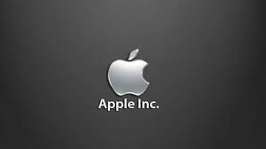

the official website of it is [www.apple.com.nin](http://www.apple.com.nin) the year2020 , the total net income was 65.339 billion dollars. Apple also serves different services like app store, cloud, iMessage, iTunes, apple books, apple fitness+, apple arcade, apple news, and Mac app store. In the year 1976, Steve jobs, wozniak and Wayne started to manufacture and sell the apple I personal computer. In the year 1976 , there sales started grew with the very high rates.

***Steve jobs***

A Steve job was the co- founder of Apple inc. he was born in the year 1995 on February 24. He was died on 5th October 2011. He was the American businessman, investor, industrial designer as well as media proper tier. He was also the chairman and CEO of Apple Inc as well as primary investor and chairman of pixer. A Steve job was also recognized as the chairman, founder and CEO of NEXT. The main course of his death was Neuroendocine cancer. He was also the personal computer revolution’s pioneer in the year1970 and 1980 and his partner on that time was Steve wozniak.



In September 2011, his total net worth was 7 billion us dollars. He was born in San Francisco which is in California. He was studied in the college Reed in the year 1972 but in the same year he was dropping out the college. In 1974, he visited India and he learns Zen Buddhism from here. Steve jobs had four children and their names are Lisa brennan-jobs. His wife’s name was Laurence Powell. In 1976, both jobs and wozniak founded the Apple and started to sold the Apple I computer which was later get more famous and they started to gain more money. Microcomputer was highly famous mass- produced.

***Apple user experience***

The experience of as an apple user is fantastic. The apple has a large variety of products like iPad, iPhone, air pods, and apple watch. These products are used mostly in nowadays. Apple has a great memory with great camera quality. By using Air pods, we can talk with other easily as it is hand free. The speed of apple products is good and these is main thing we all needed as the modern life is very fast and the apple open any apple quickly. The apple has a security features and it contains fingerprint lock and password lock. It is very difficult to crack I phone lock. As a apple user, we all like the siri. In siri application, we just have had to give commands through voice and after that siri recognize our voice then it started to complete that work. Apple has large variety of applications and it has its own market place which we all like as a apple user.

***Reference:-***

<https://www.biography.com/business-figure/steve-jobs>

<https://developer.apple.com/swift/>

<https://en.wikipedia.org/wiki/Objective-C>

***PART 2***

***What is Xcode***

X code is the IDE(integrated development environment ) of apple for macOs which is used to build different software’s for tvOs, iPadOs , watchOs. The developers of Xcode are Apple Inc. it was firstly released in the year 2003. Its current version is 12.5.1 which was released on 21st June in the year 2021.. we can download it from Mac app store or we can say that it is available free of cost on macOs app store for the users of macOs Big Sur. Xcode is run only on macOs operating system. the official website is developer.apple.com. The developers that have registration can download its preview versions and prior releases via the official website of Apple developer. Command line Tools are included in Xcode. it is used to activate Unix-style development through the terminal application which is available on macOs. We can also install and download it without any need of IDE. Xcode is used to as the official supported tool to create and launching the applications on app store of apple Inc. it is build for the use and it is used by both the experienced and beginners developers. Xcode support different variety of languages and this languages can be Objective-C, objective-C++, C++, Python, Swift, Java, AppleScript, ResEdit, Ruby. . Xcode has different tools which are used to develop the software. this tools are used to write, compile as well as for debugging our application. This tools can be text editor, build system and compiler. When everything is completed , we can submit the application on app store.

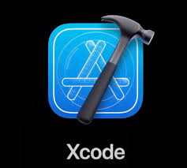

***Capabilities of Xcode****:-*

the capabilities of xCode is as follows:-

* **Source Editor: -** the advanced and professional editor to write a code is easy with latest code completion, highlighting the syntax as well as with code folding and bubbles messages
* **Asset catalog-** The asset catalogue builder in Xcode organises your app's pictures by collecting them together in higher scales. Xcode combines the asset catalogue into a much more appropriate package for ultimate distribution when creating it.
* **Assistant Editor**- The Assistance tab divides the editor into two panes, one of which instantly shows files which are most useful to you depending on the coding you're now working. It may display the counterpart of the header, the subclass, caller, callees, as well as other useful files.
* **Open Quickly-** To open any file in your workspace using the main editor, just press Cmd-Shift-O, or hold the Option key when choosing a file to access it in the Assistant director. In every keyboard-driven workflow, Open Quickly is a must-have tool.
* **Compilers:;-**  the different compilers of LLVM which are used for the languages like C, C++, and objective-C and these are the open source compilers are developed into Xcode as well as it is available at terminal. By using it , the code is easily and quickly compiled.
* **Stimulator-** Xcode can developed as well as it can install and run the touch applications of Cocoa in simulator which is based on Mac by using the iOS SDK .

**User interface of Xcode**

the interface builder in XCode helps to build interface without writing any code. The developer just follows the drag and drop policy. In this policy , we just simply drag and drop text fields, buttons , windows as well as any other different objects at the canvas design to build the user interface functioning. It is easy to design the interface independently as the both cocoa and cocoa touch is developed by using the pattern of Model-View-controller so we can separate the implementations of interface. The MacOs and iOS build the connection between both code and UI dynamically when the application is in the running position.

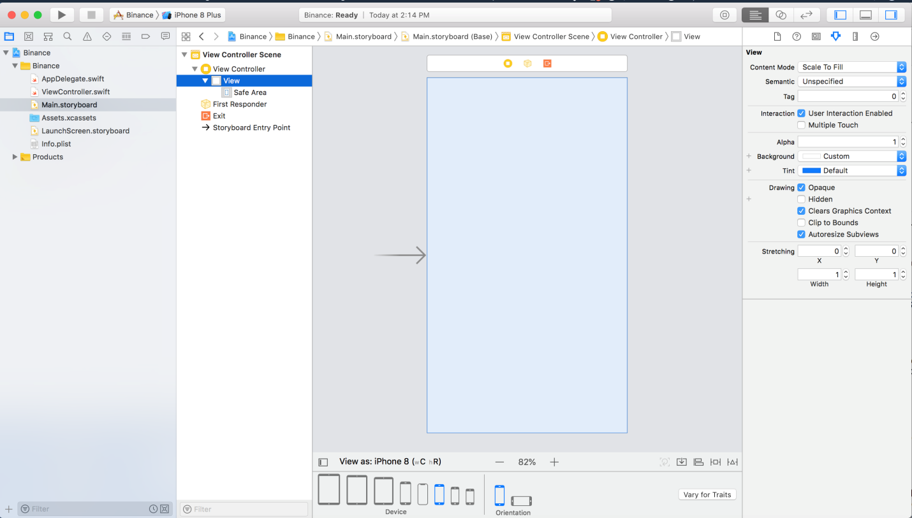

**Fonts and colors**

the code that is used which is based on the language is breakdown by xCode as well as Syntactic label is given to every string by it. lets take an example, in the project, every keyword , comment as well as the name of class is clearly defined. The font and color is assigned by the xCode to every syntactic type so it makes very easy for the user to read the code easily. 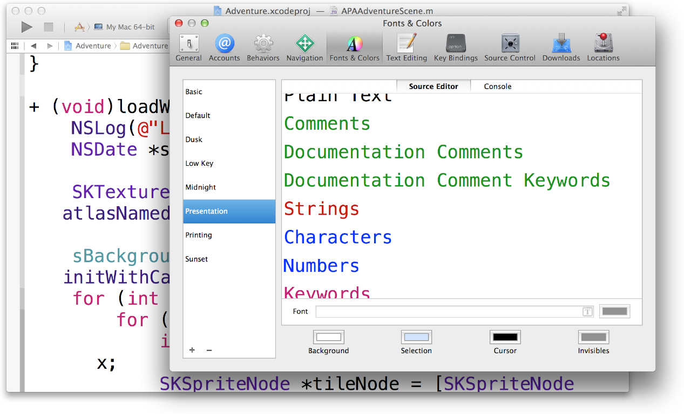

We can also select different fonts and color themes by selecting Xcode then we click at preferences after that we select fonts and colors.. let’s take an example of presentation, when we increase the font size by changing the themes then it is very easy to read the text which is displayed on the large screen. xCode also gives us the opportunity to create our own theme with our own font style and color. The user can also do editing on the text by selecting xCode option then select text editing to modify option under the preference option.

**Tab bar**

the interface of tab bar which is at the window’s bottom area is used to choose different modes as well to display the view area of selected mode. The class is used as it is but it also gives the opportunity to subclass it. we can say that the container view handles the multivew interfaces, every tab bar of the interface controller is connected with the controller of custom view. The tab bar automatically controls and shows the actual root view and it replace the old views when the user choose its particular tab. The selected tab replace the contents of previous selected tab. The interface of tab bar is used to display the actual information or the same information with different styles. The user cannot directly get the access of tab bar view which is related to tab bar controller. To make changes in the tabs of the tab bar controller , the user needs to give the view controller which helps to assign root view to view controllers of each tab with clear manner. When we specify the view controllers in such order then it the checks the order of appearance in which order the views are displayed.

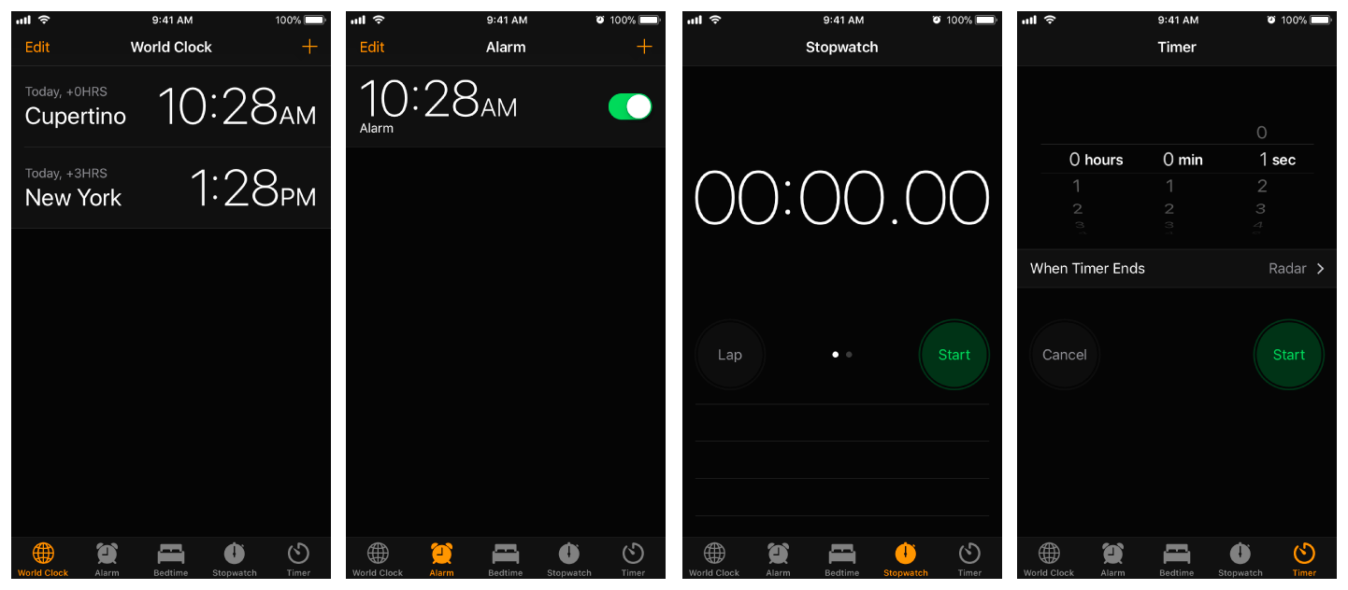

The picture has tab bar interface which is shown in clock app. Every singal tab is based on time information.

**Options:-**

xCode provides different options to glare. we can do their work within xcode project context to build the iOS application. We cannot do changes if they don’t have programming knowledge as well as experience. The user can set the preferences by following different steps. Firstly, we have to open xCode then under the main menu, select preferences. After that, select behavior tab which is available at the top in the preferences window .in the third step, click at the generate output which is available at the left column.

**Editor**

editors in the xcode is used to make editions. In xcode , the maximum work that the developer make shows in the editor area. This is the main area and within the workspace window .when we select the particular file from the navigator’s content area then the file in xCode is automatically open in the related editor. this main area is always shown. The most common editors are as follows:-

* **Project editor: -** this editor is used to edit and view that how the user applications can be developed such as, by adding the target architectures, build options as well as entitlements of application.
* **Interface builder:-** it is used to build and edit the files of user interface graphically.
* **Source editor:-** it is used to perform writing and editing on source code.

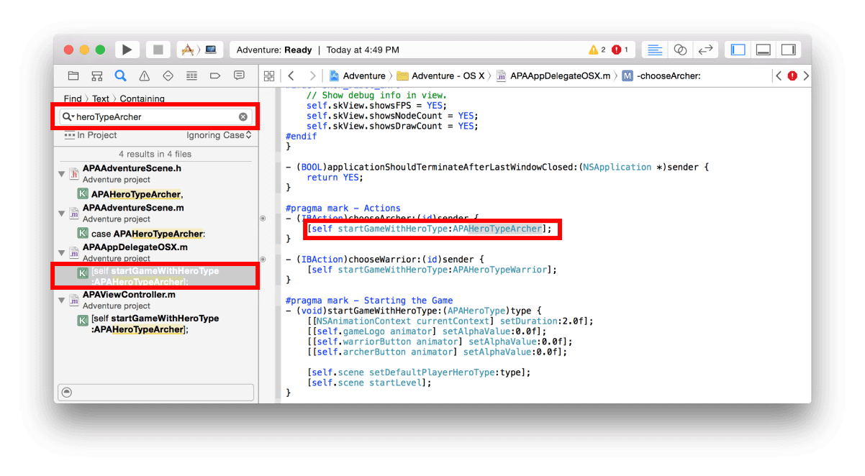

The image shows the different search results that are shown on the content area of navigator. The string of text is shows on source editor when one of the result is chosen.

**Project view**

The selection bar, the area which has content, as well as the Filter bar are all found in the project view section. Other features that are unique to the chosen navigator can also be contain by it.. You may use the Program navigator to remove, create, group, and the other different file types in your project, as well as choose a file to read or edit in the Editor section.

**Other tools**

There are some different tools are available that are used to develop an application. These tools are grouped as additional tools for xCode. These tools are:-

* **Network link conditioner: -** it restores the network which is bad like Edge or DNS.
* **Repeat after me:-** this tool is used to change the text that the user use into the sound as well as phonemes. Apart from it, the user can also change and adjust frequency according to points that are on the graph.
* **Pixie: -** pixie tool is worked as the high magnifier the screen of user.

**REFRENCES:-**

[**https://developer.apple.com/documentation/uikit/uitabbarcontroller**](https://developer.apple.com/documentation/uikit/uitabbarcontroller)

[**https://developer.apple.com/library/archive/documentation/ToolsLanguages/Conceptual/Xcode_Overview/EditingYourFiles.html**](https://developer.apple.com/library/archive/documentation/ToolsLanguages/Conceptual/Xcode_Overview/EditingYourFiles.html)